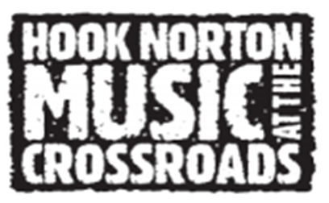 | Hook Norton Charitable Association  c/o Amanda Watkins  Little Bowden  The Bourne  Hook Norton  OX15 5PB  Email: ajwat99@aol.com  Tel: 07710296433

Music At The Crossroads - Vendor Interest Form 2024
Vendor Name:

Address:
Phone: |  | Email

Additional Stall holder name:

Many thanks for your interest in attending our Festival – Friday 5th to Sunday 7th July 2024. Please let me know what type of stall you have. If we decide to proceed further, a Vendor Agreement Form will be sent to you

Are you able to provide the following:

- Copy of Public Liability
- Copy of Food Trader License (if applicable)

Which days would you be able to attend (please circle / highlight one):
- Friday to Sunday inclusive
- Friday only
- Saturday only
- Sunday only
- Friday and Saturday
- Saturday and Sunday

Payment Information
There is a scale of charges dependent upon type of vendor. This charge is for the whole weekend regardless of how many days trading and does NOT include any power required.  Food stall - £80.  Small food / drink eg tea and coffee - £40  Alcoholic beverages - £160  Clothing / jewellery/ sundries - £30  Charity stalls – Free of Charge (but still need to be booked plus there may be a charge for power if required).  Children’s entertainment – 10% of all takings (plus charge for power supplied). |  | From: |  | To:
Please DO NOT make any payment until it has been agreed that you will be attending the event. Please ensure you contact AMANDA WATKINS to discuss this further. Please note that your booking will not be fully confirmed until payment is received in full

